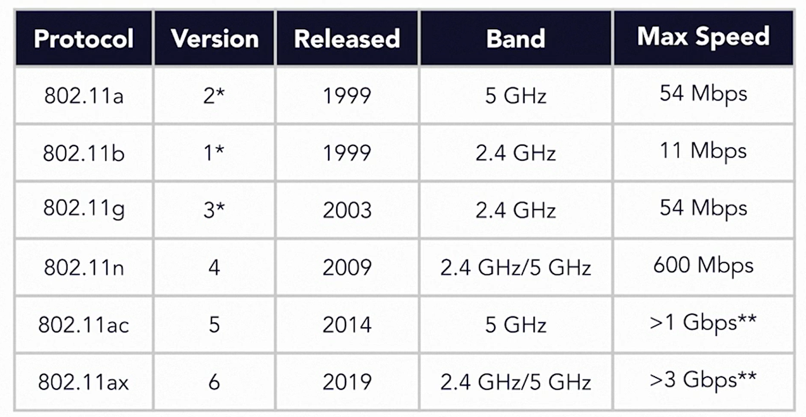

Wifi – 4, 5 and 6 are last three.

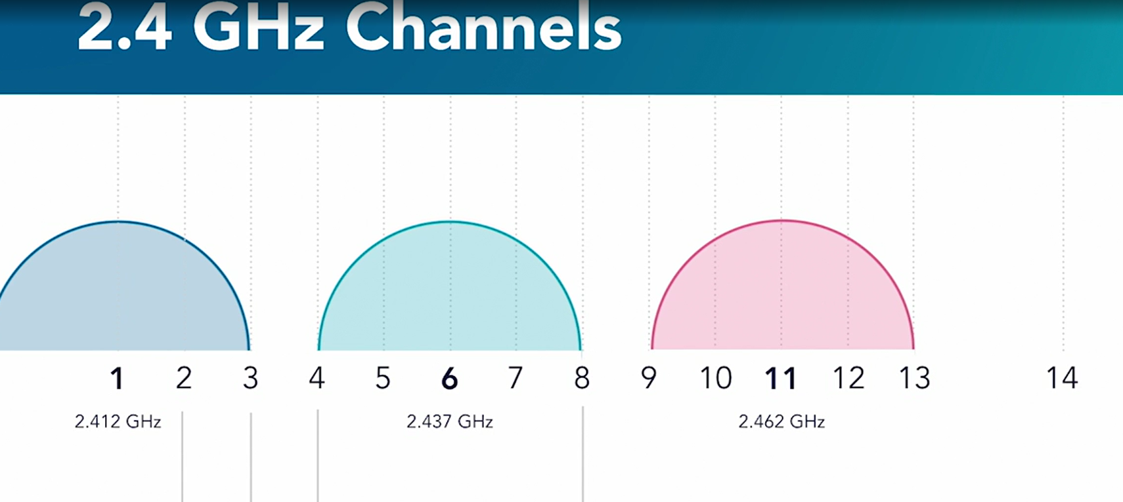

Channel 14 is only allowed in Japan and Indonesia and that also for 802.11b.

You won’t find it being used, atleast not legally.

Channels are 5 MegaHertz wide.

Overlapping channels lead to “Interference”.

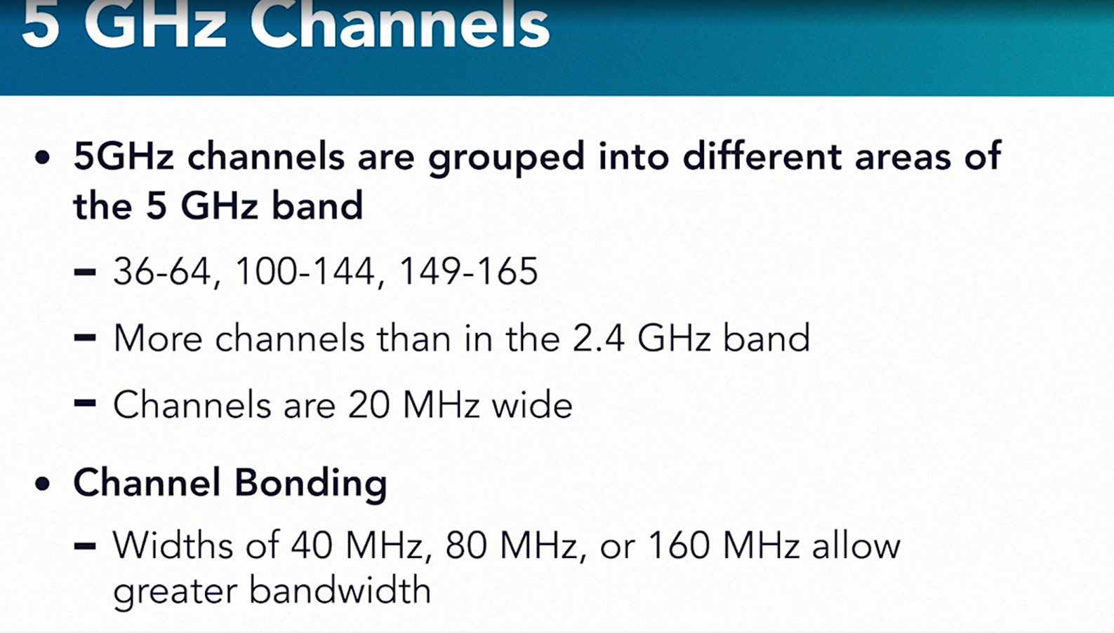

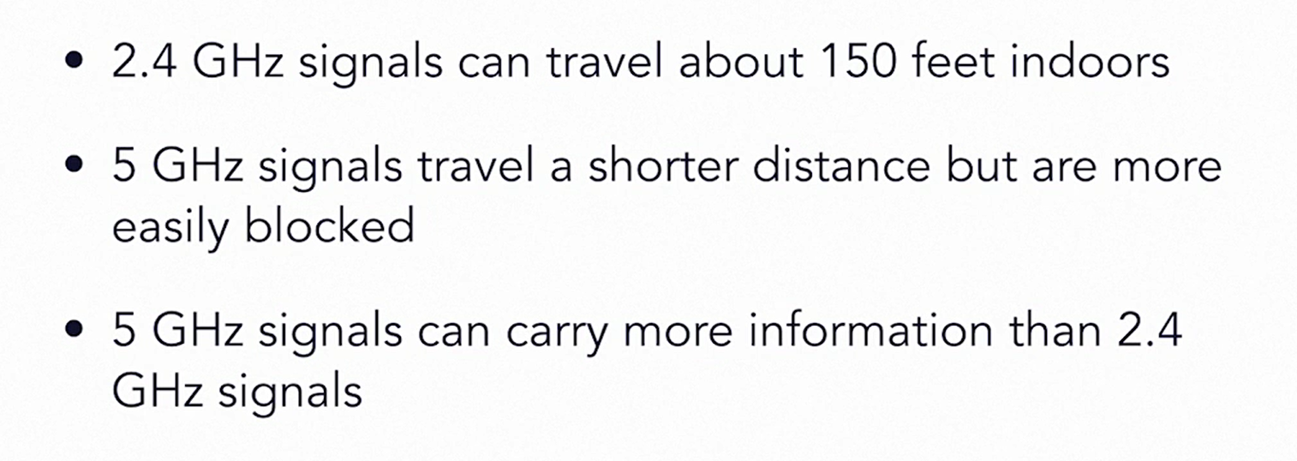

RSSI: Received Signal Strength Indication, calculated by devices when receiving signal from client.

Wi-Fi uses radio waves in the microwave spectrum to transmit information between stations, or clients.

SSID: Service Set Identifier(network’s name)

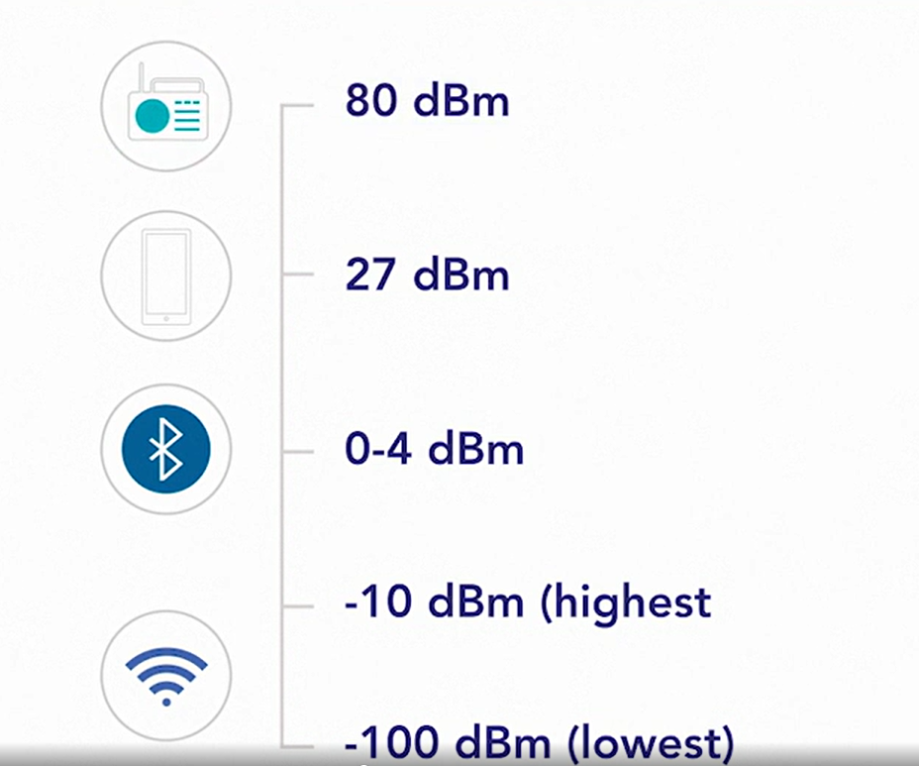

RSSI closer to -10dBm and noise the closer to -100dbm, the better.

Ex: noise = -80dbm RSSI = -30dbm

SNR(Signal – to – Noise Ratio) Width = 50dbm (the wider the better signal)

Walls and other objects reduce the signal.

insider

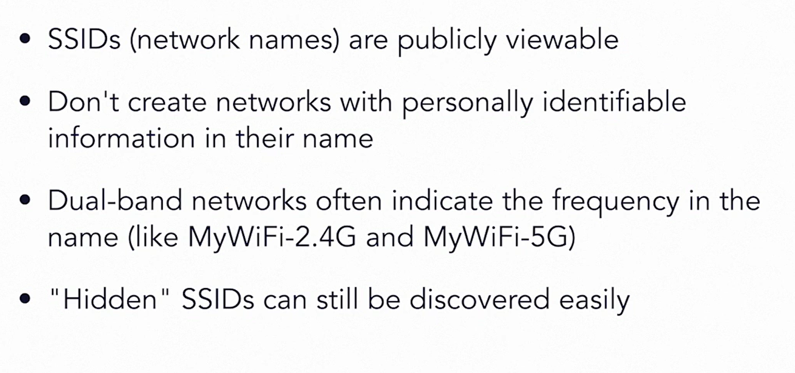

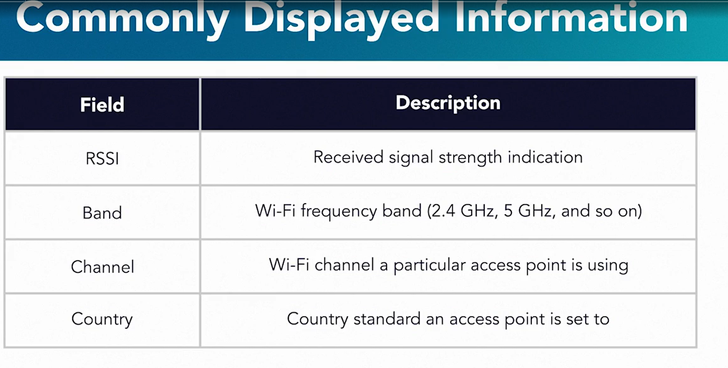

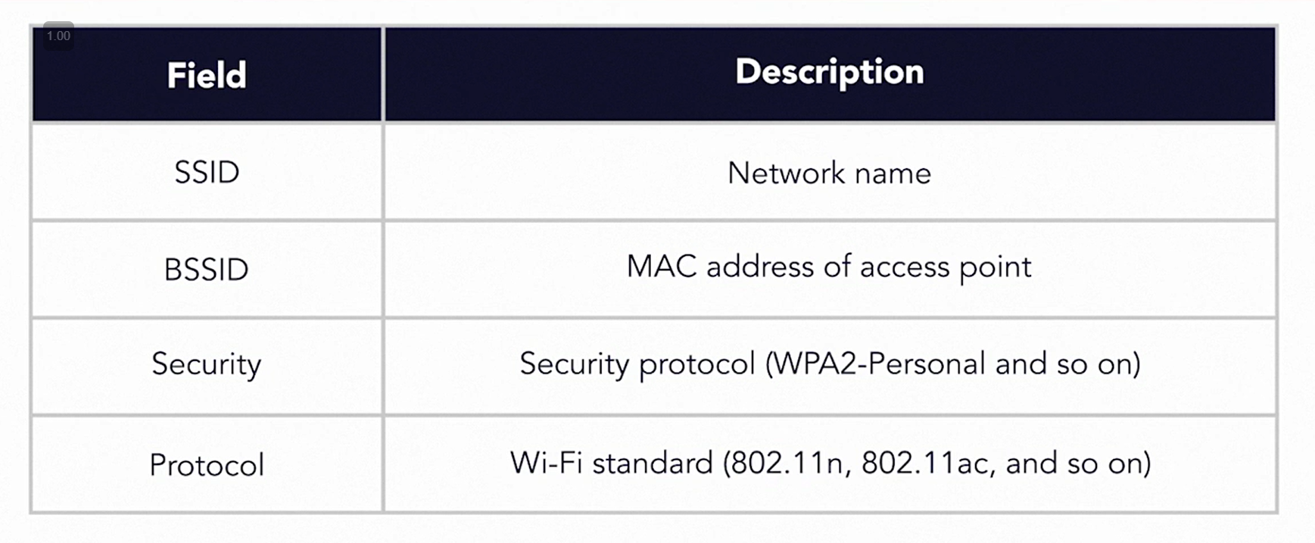

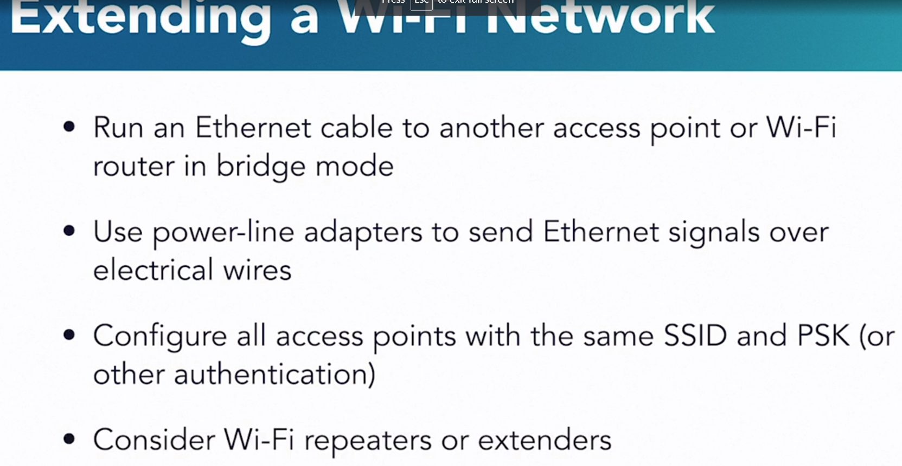

When the name and key are the same, multiple access points appear to provide one large Wi-Fi network.

